Chapter 16: Controller Design Using Frequency Response Criteria

Advantages of FR Analysis:
- Applicable to dynamic model of any order (including non-polynomials).
- Designer can specify desired closed-loop response characteristics.
- Information on stability and sensitivity is provided.

Disadvantage:
The approach tends to be iterative and hence time-consuming -- interactive computer graphics desirable.

Controller Design by Frequency Response - Stability Margins
Analyze 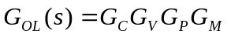 (open loop gain)
Four methods in use:
- Bode plot 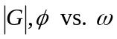 (open loop F.R.)
- Nyquist plot - polar plot of 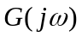
- Inverse Nyquist plot - polar plot of 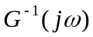
- Nichols chart 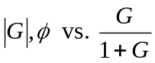 (closed loop F.R.)
advantages:
- do not need to compute roots of characteristic equation
- can be applied to time delay systems

FR Characteristics of Controllers
Recall that the FR is characterized by:
- Amplitude ratio, AR
- Phase angle,
For any T.F., G(s)
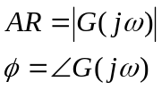
- Proportional Controller
Here, 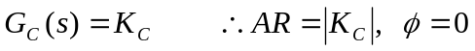
- PI Controller
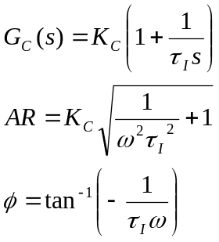
The Bode plot for a PI controller is shown on Fig. 16.1. Note 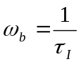. Asymptotic slope 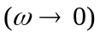 is –1 on log-log plot.
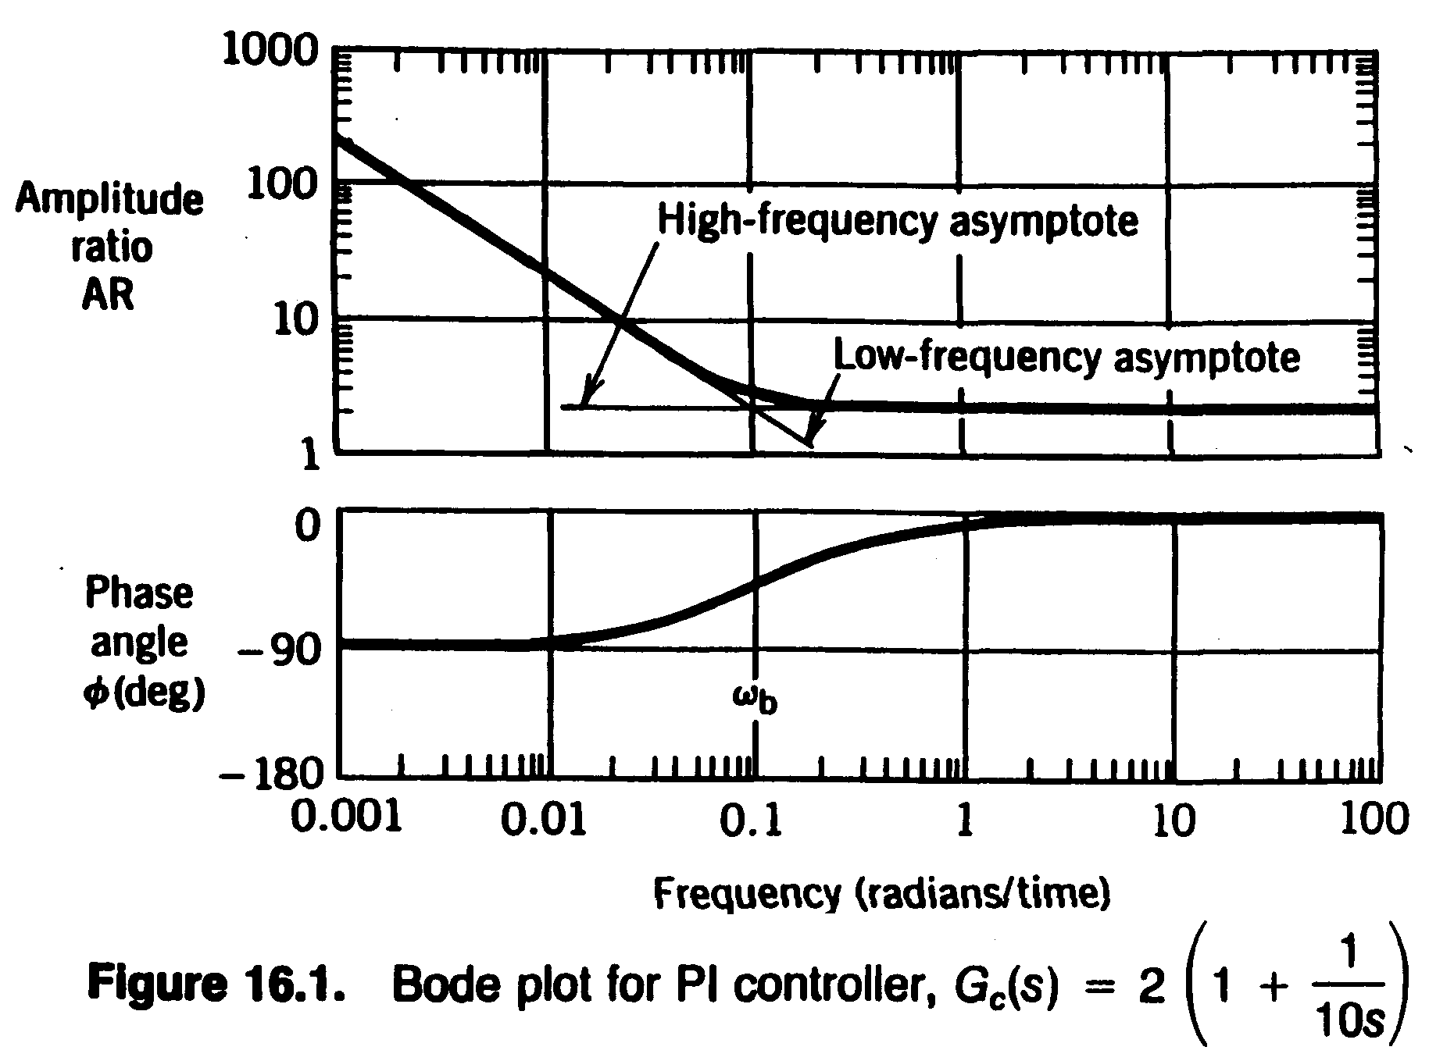
- PD Controller
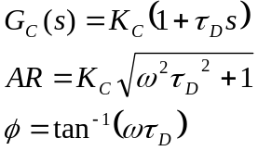
Note: 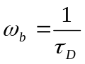 and high frequency asymptote 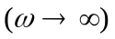 has slope +1. See Figure 16.2.
- Ideal PID Controller
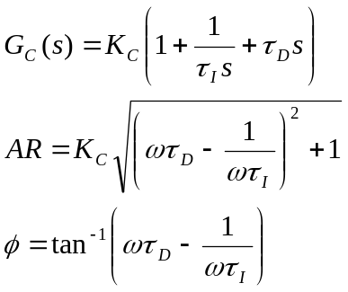
See Figure 16.3. Includes asymptotes of PI and PD controllers.
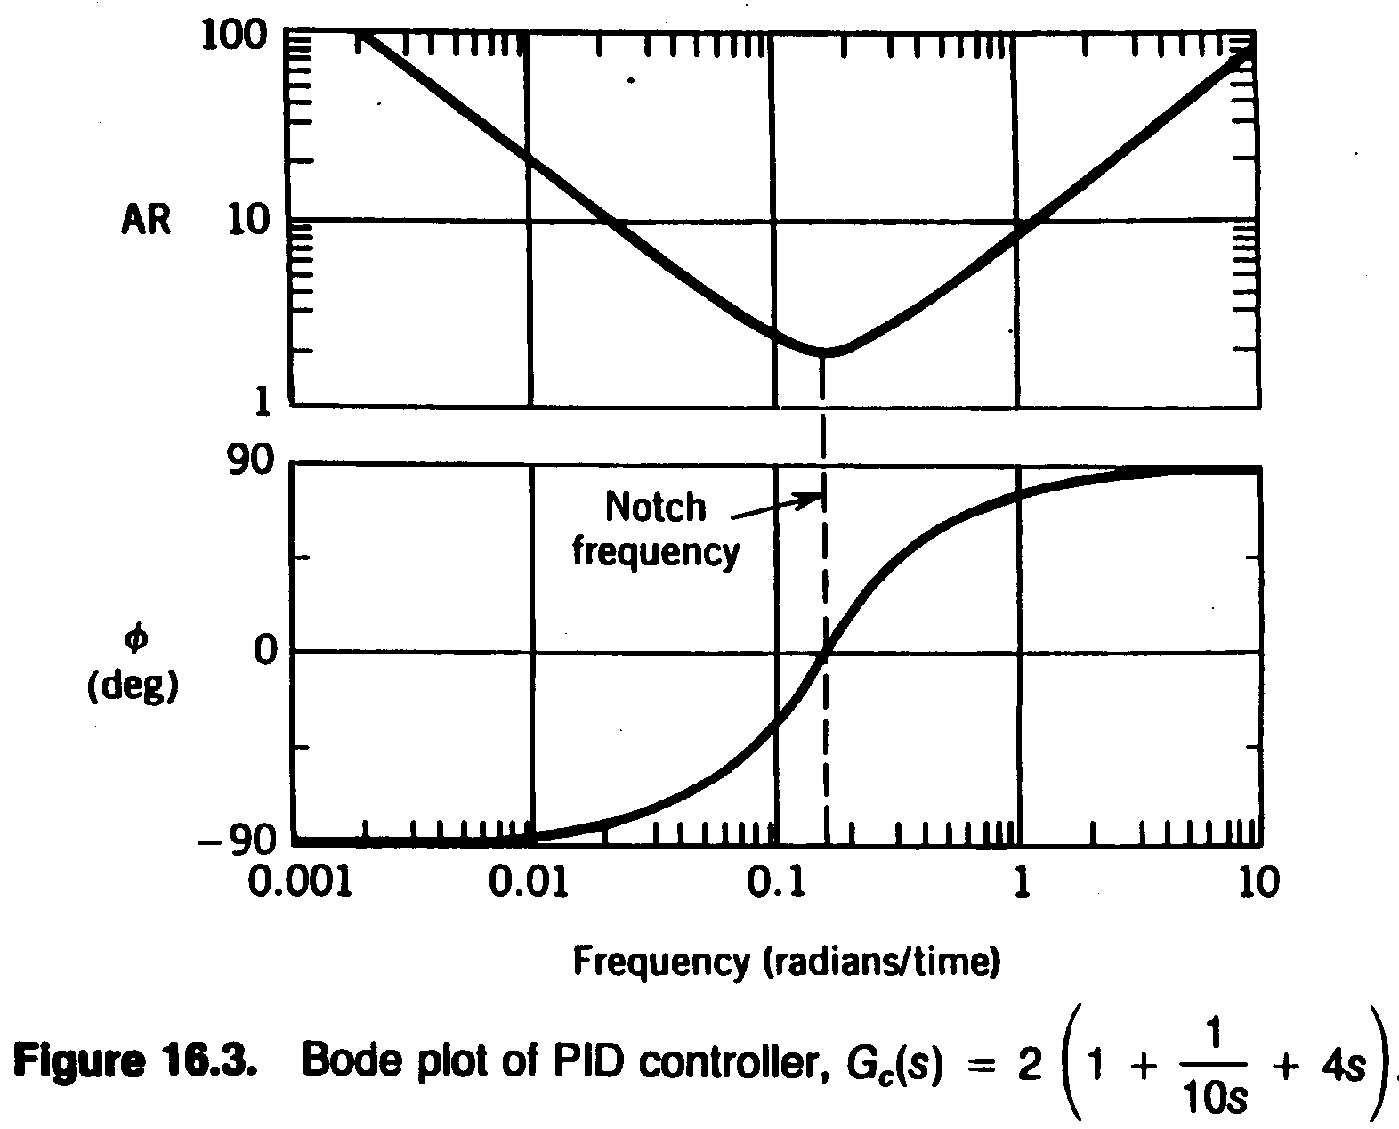

Controller Design Using Frequency Response Criteria
Advantages of FR Analysis:
- Applicable to dynamic model of any order (including non-polynomials).
- Designer can specify desired closed-loop response characteristics.
- Information on stability and sensitivity is provided.
Disadvantage:
The approach tends to be iterative and hence time-consuming -- interactive computer graphics desirable.
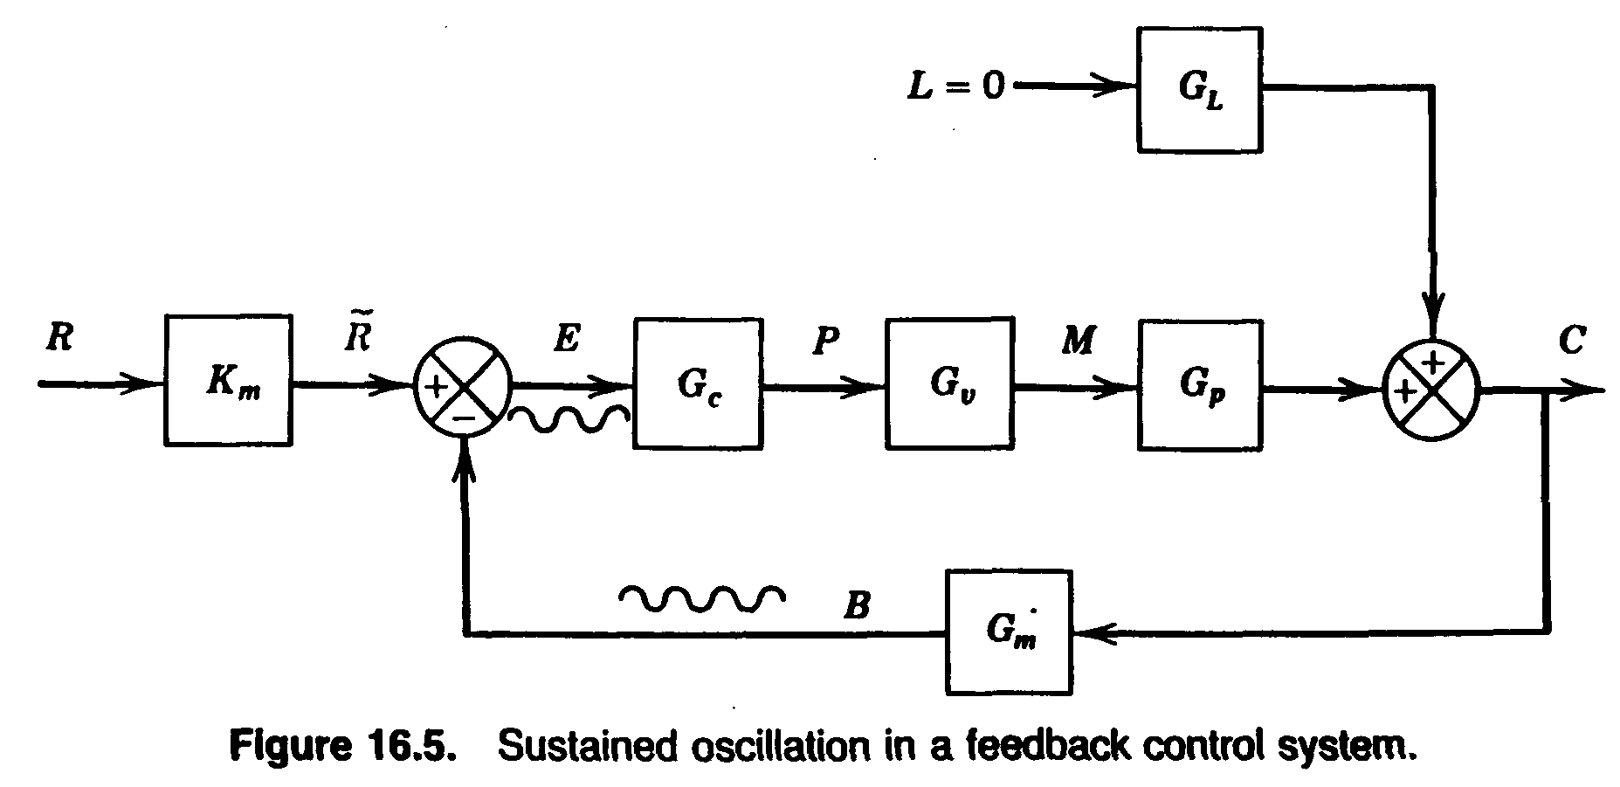

Frequency Response Stability Criteria
Two principal results:

Bode Stability Criterion
- Nyquist Stability Criterion

- Bode stability criterion
A closed-loop system is unstable if the FR of the open-loop T.F. has an amplitude ratio greater than one at the critical frequency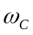. Otherwise the closed-loop system is stable.
- Note: 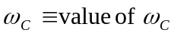where the open-loop phase angle is -180⁰. Thus
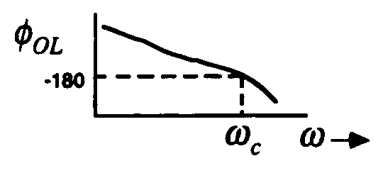
- The Bode Stability Criterion provides info on closed-loop stability from open-loop FR info.
- Physical Analogy:
Pushing a child on a swing or bouncing a ball.
Example:
A process has a T.F.:
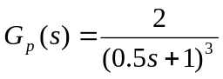
and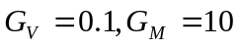, if proportional control is used, determine closed-loop stability for 3 values of K_{C}: 1, 4 and 20.

Solution:
The OLTF is or,
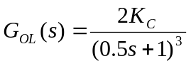
The Bode plots for the 3 values of K_{C} shown in Fig. 16.6. Note the phase angle curves are identical. From the Bode diagram:
K_{c} | AR_{OL} | Stable?
1 | 0.25 | yes
4 | 1.0 | conditionally stable
20 | 5.0 | no

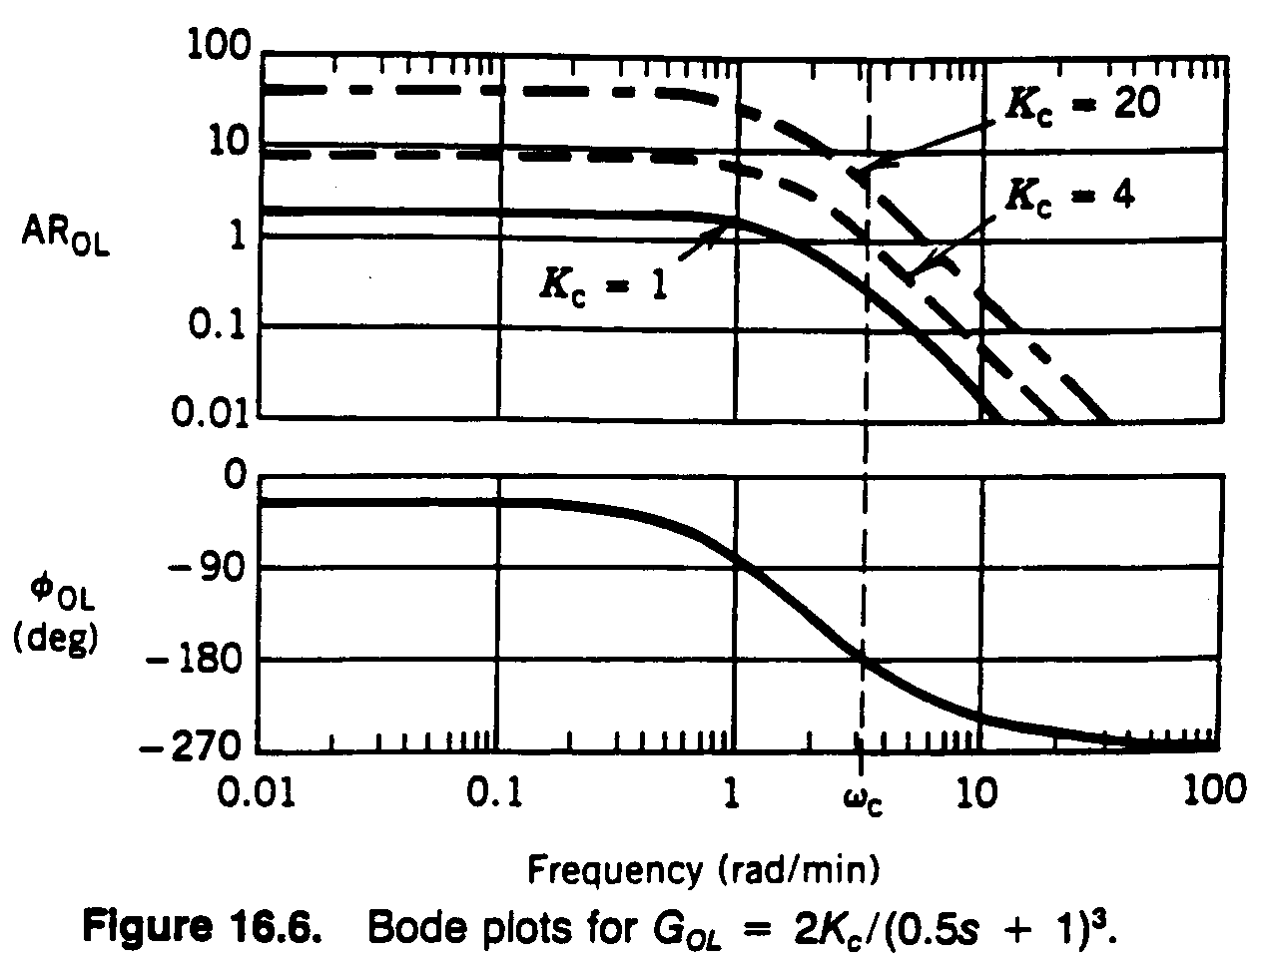

Example 16.3
Determine the closed-loop stability of the system,
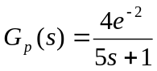
where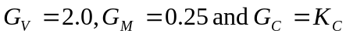. Find from the Bode diagram. What is the maximum value of K_{C} for a stable system?

Solution:
The Bode plot for K_{C} =1 is shown in Figure 16.8. Note that:
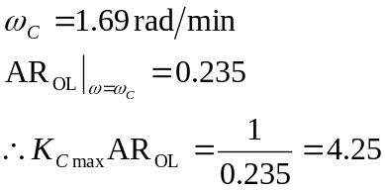
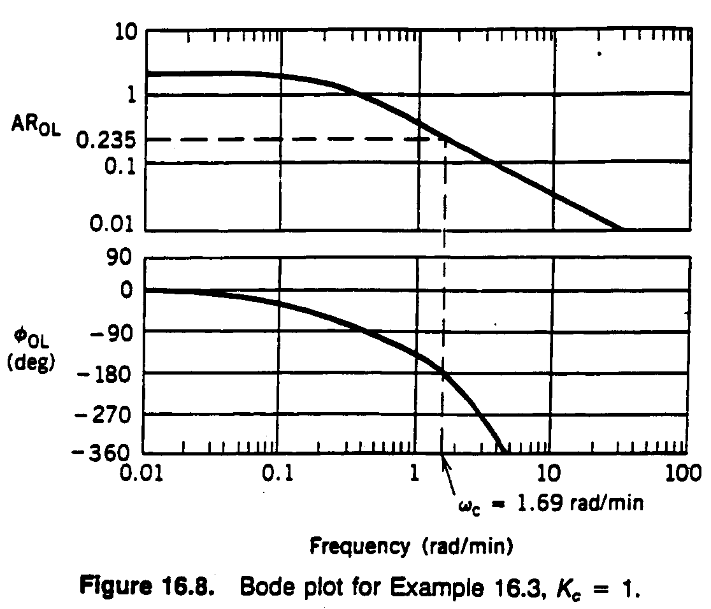

Ultimate Gain and Ultimate Period
- Ultimate Gain: 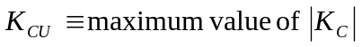 that results in a stable closed-loop system when proportional-only control Is used.
- Ultimate Period: 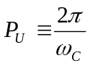
- K_{CU} can be determined from the OLFR when proportional-only control is used with K_{C} =1. Thus
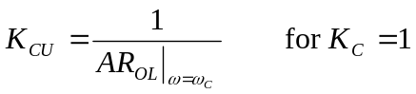
- Note: First and second-order systems (without time delays) do not have a K_{CU} value if the PID controller action is correct.

Gain and Phase Margins
The gain margin (GM) and phase margin (PM) provide measures of how close a system is to a stability limit.
- Gain Margin:
Let 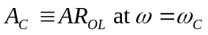. Then the gain margin is defined as: 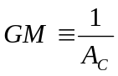
According to the Bode Stability Criterion, 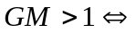stability
- Phase Margin
Let 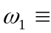 frequency at which 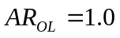 and the corresponding phase angle is 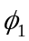. The phase margin is defined as: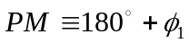
According to the Bode Stability Criterion, 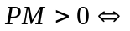 stability
See Figure 16.11.
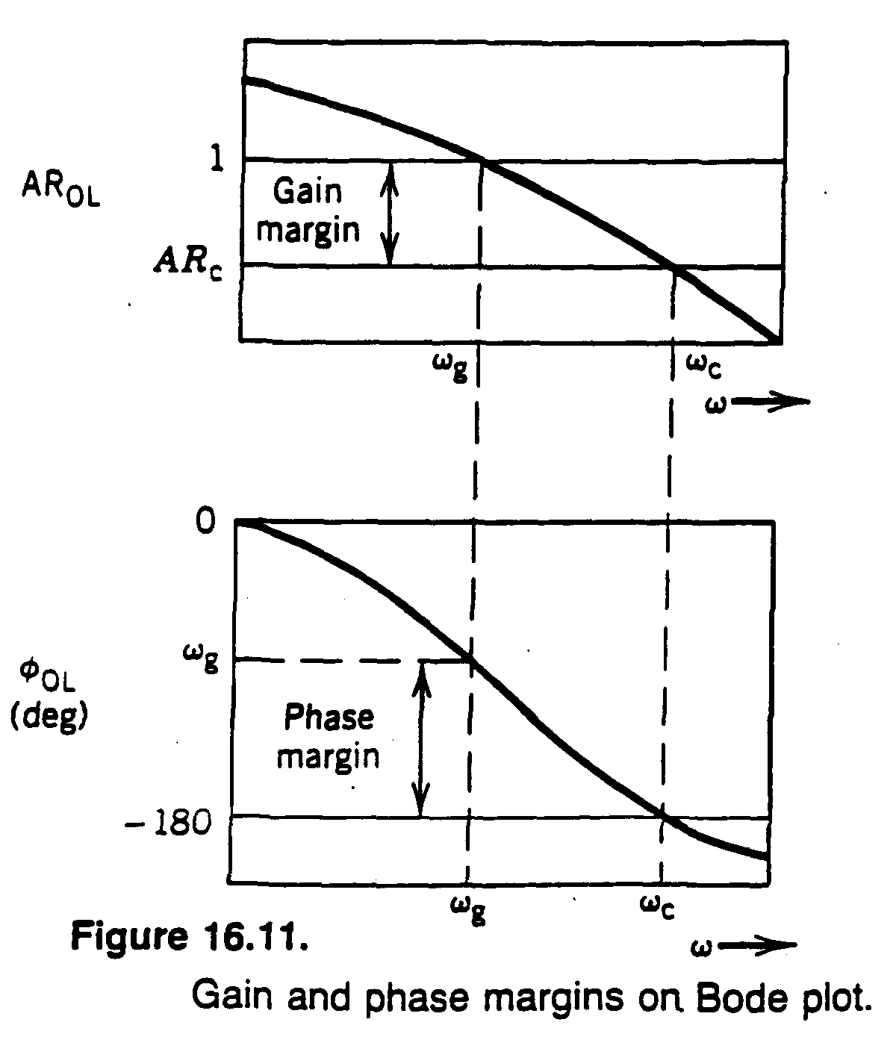

Rules of Thumb:
A well-designed FB control system will have:
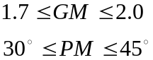

Gain-Bandwidth Criterion:
It can be argued that a well-designed control system should maximize the product 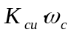. For example, for load changes:
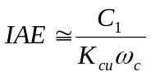

Closed-Loop FR Characteristics:
An analysis of CLFR provides useful information about control system performance. Typical desired CLFR for setpoint changes and the corresponding step response are shown in Figure 16.13.
